

Announcement of Phu Ruea Police Station

Subject : Intention to not accept any kind of gifts from performing duties

(No Gift Policy)

**………………………………………………….**

Phu Ruea Police Station is determined to develop transparent operations, adheres   
to common interest more than personal interests and without conflict of interest in accordance with the National Reform Plans on Prevention and Suppression of Corruption and Malfeasance (Revised Edition), which aims for agencies to operate with transparency, without conflict of interest. All government officials shall not accept any kind of gifts from performing duties. (No Gift Policy)

Therefore, we would like to announce the intention of the Superintendent of Phurua Police Station and all police officers to not accept gifts or gifts of any kind from performing duties. (No Gift Policy). We will together establish organizational culture and integrity value at work, not accepting the patronage system, avoiding actions that may affect discretion or decision-making during performing duties that would lead to discrimination. Also, we cooperatively prevent the unfair performance of duties and conflict of interest along with building public trust by performing our duties with good governance.

It is hereby announced and to strictly adhered to all.

This announcement is hereby issued on February 13st , 2024

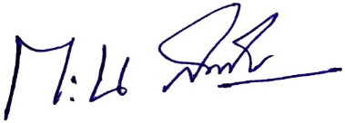

Police Colonel

( Weeraphan Somsuk )

Superintendent of Phurua Police Station